M02 Chapter 4 Hands On Projects

- Hands On Project 4-1
  - Screenshot of initial ARP cache
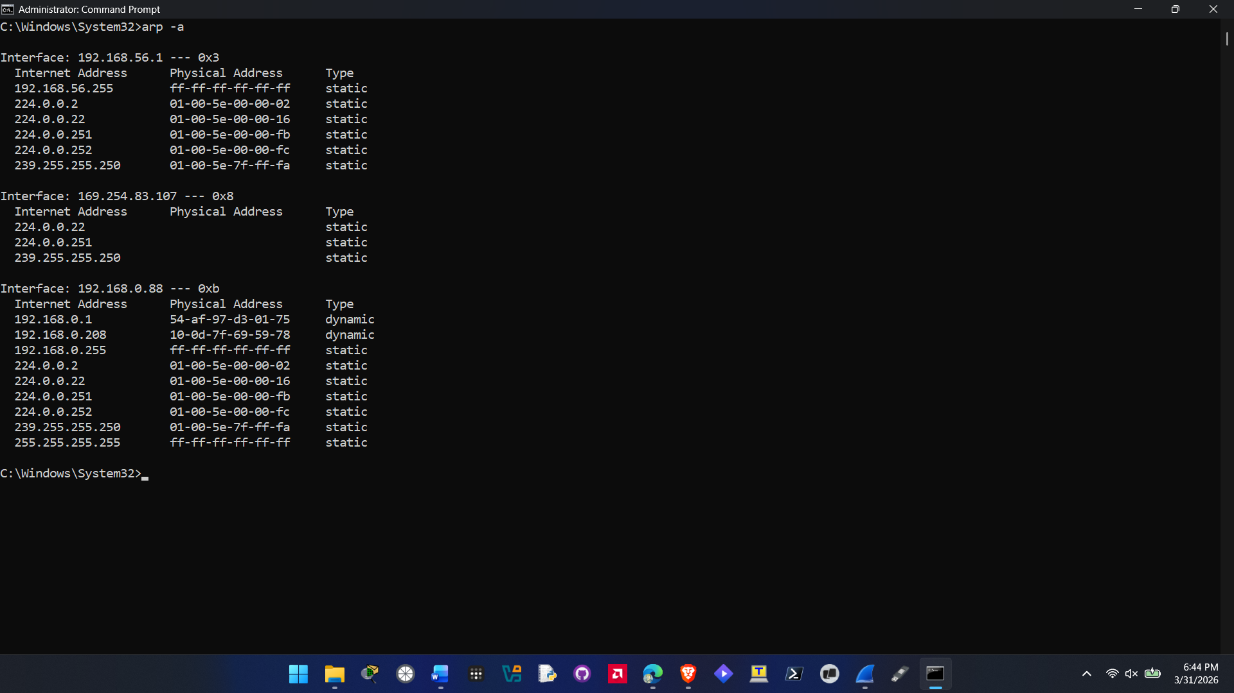
  - Screenshot of revised ARP cache
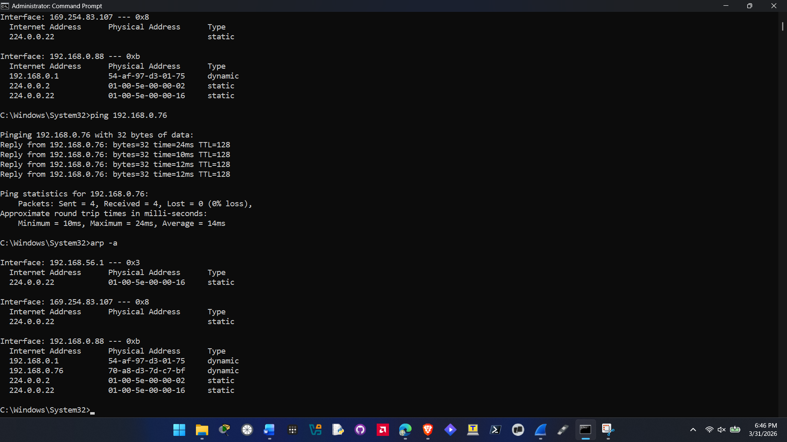
- Hands On Project 4-2
  - Screenshot showing netsh output
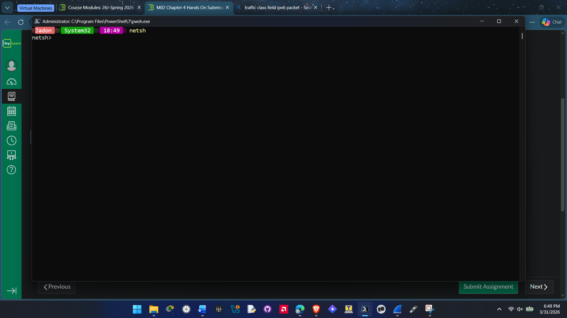
  - Screenshot showing routes
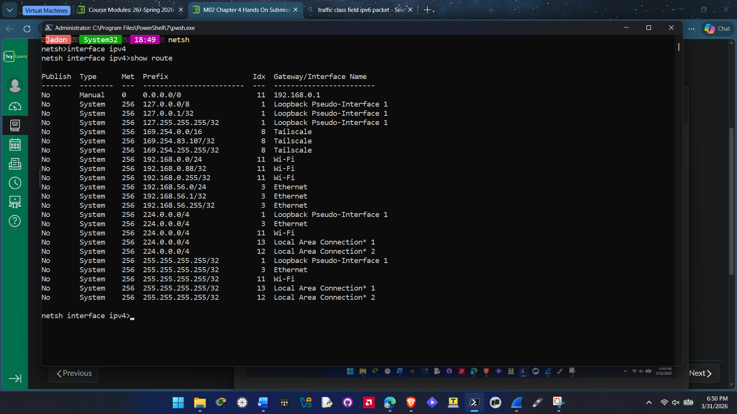

- Hands On Project 4-3 (if you do not have IPv6, attach screenshot of ipconfig showing so in place of lab)
  - Screenshot showing netsh output
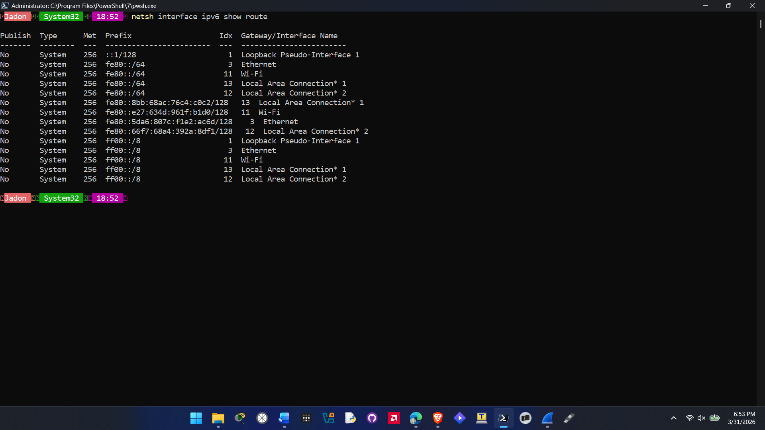
  - Screenshot showing neighbors
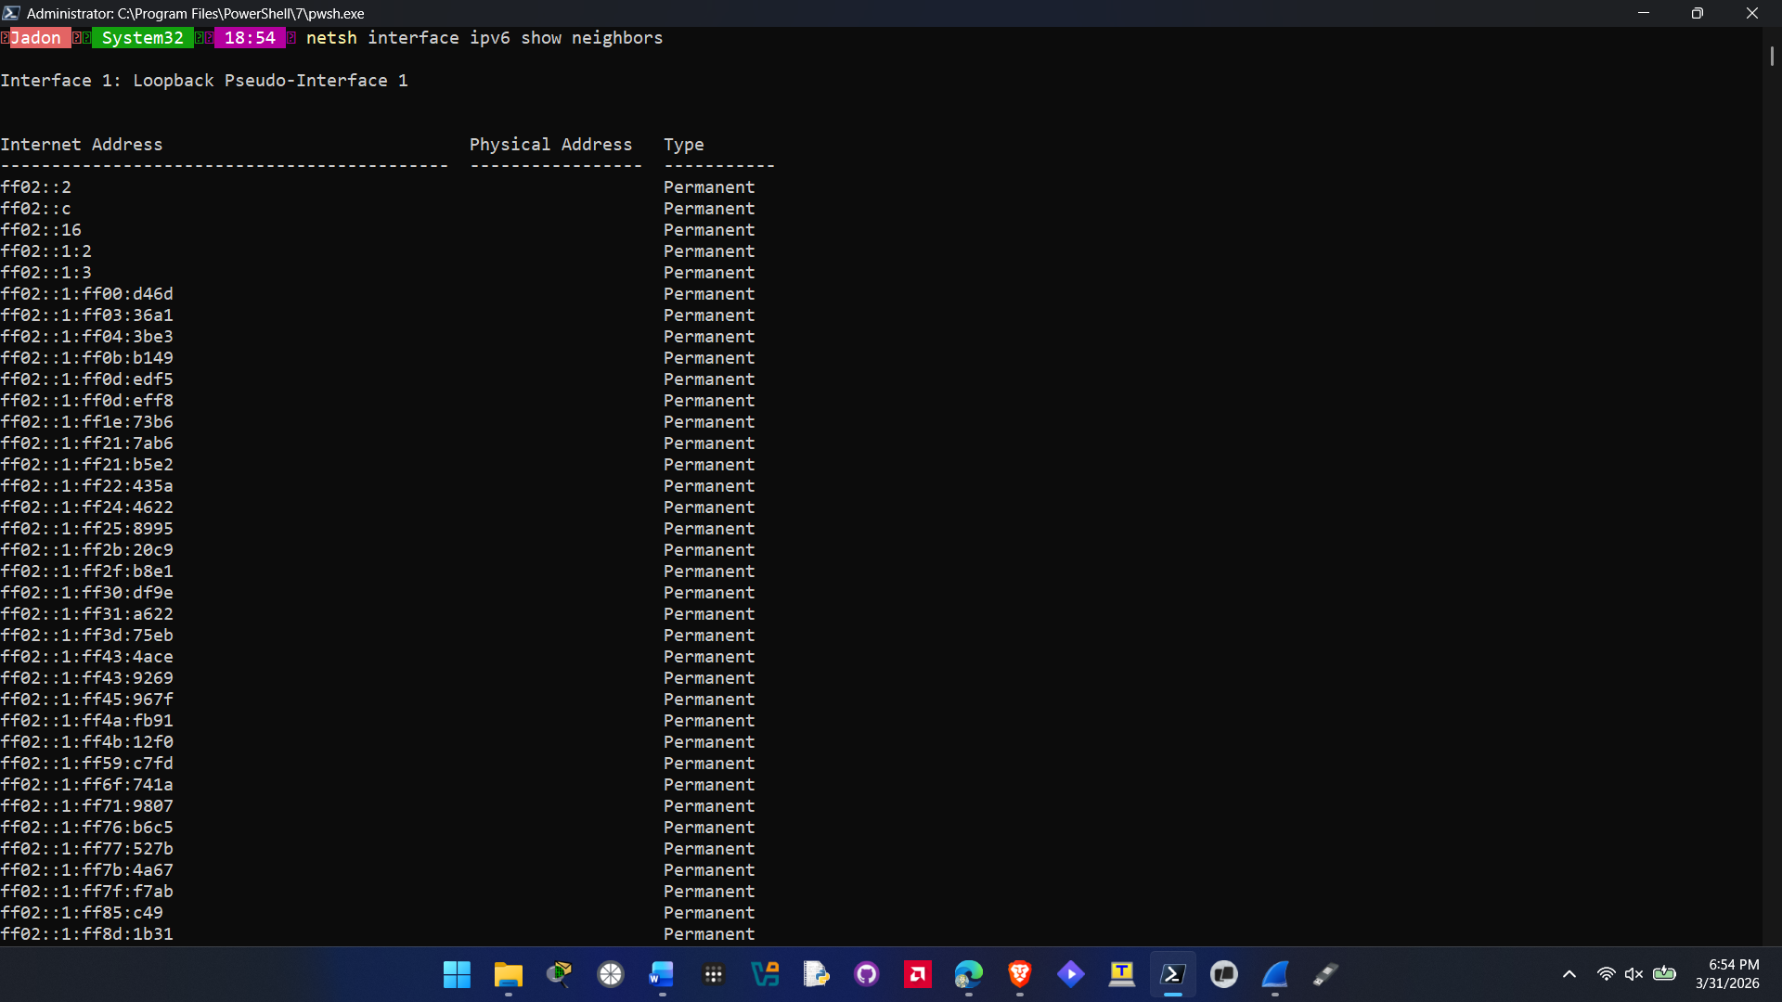
- Hands On Project 4-4 (same thing with IPv6 as above, but skipping just IPv6 portions)
  - Please use the sample captures in the module after you download them, as they are no longer available online.
  - Screenshot of RIP request packet with items expanded as requested
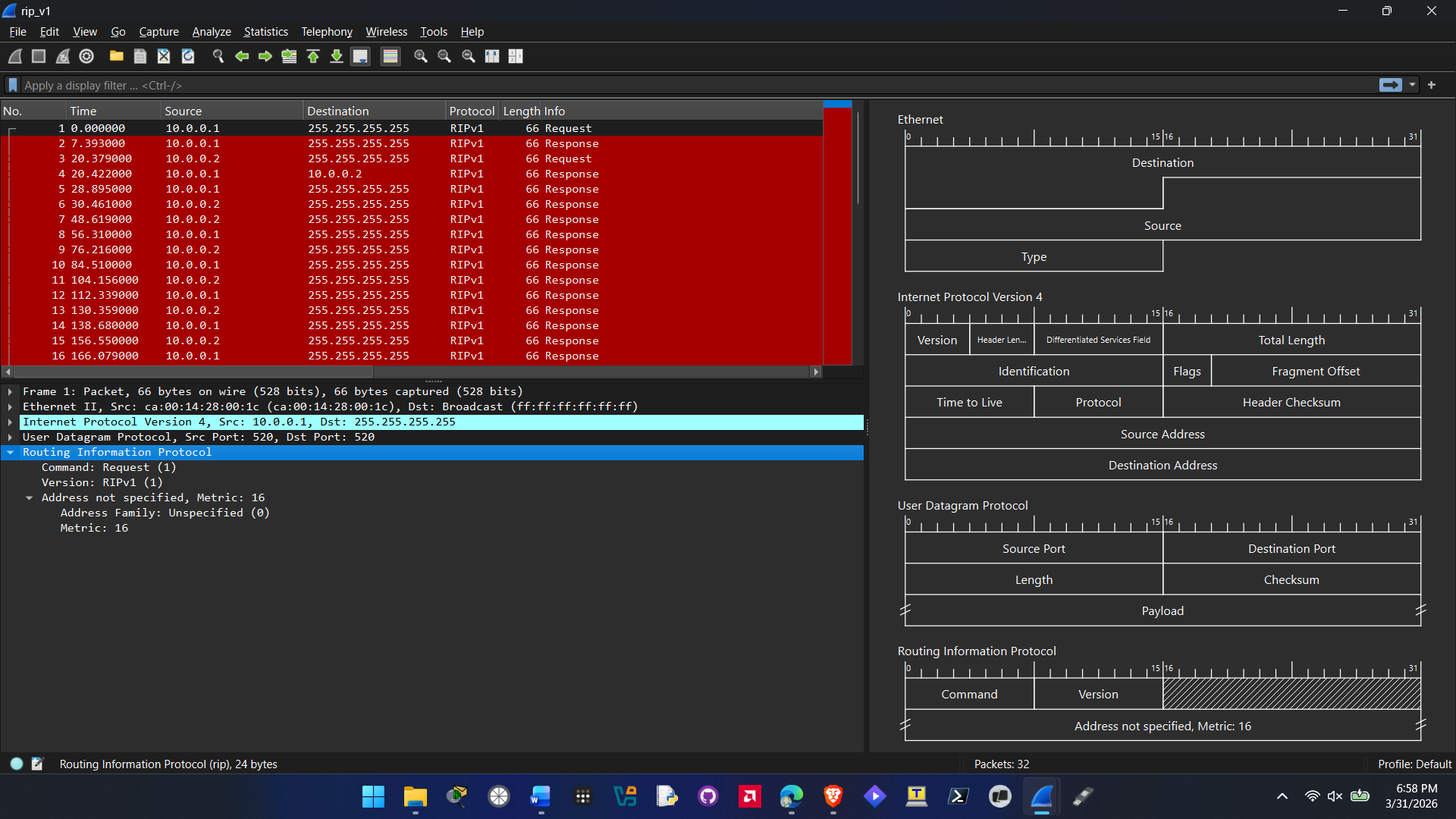
  - Screenshot of OSPF hello packet with items expanded as requested
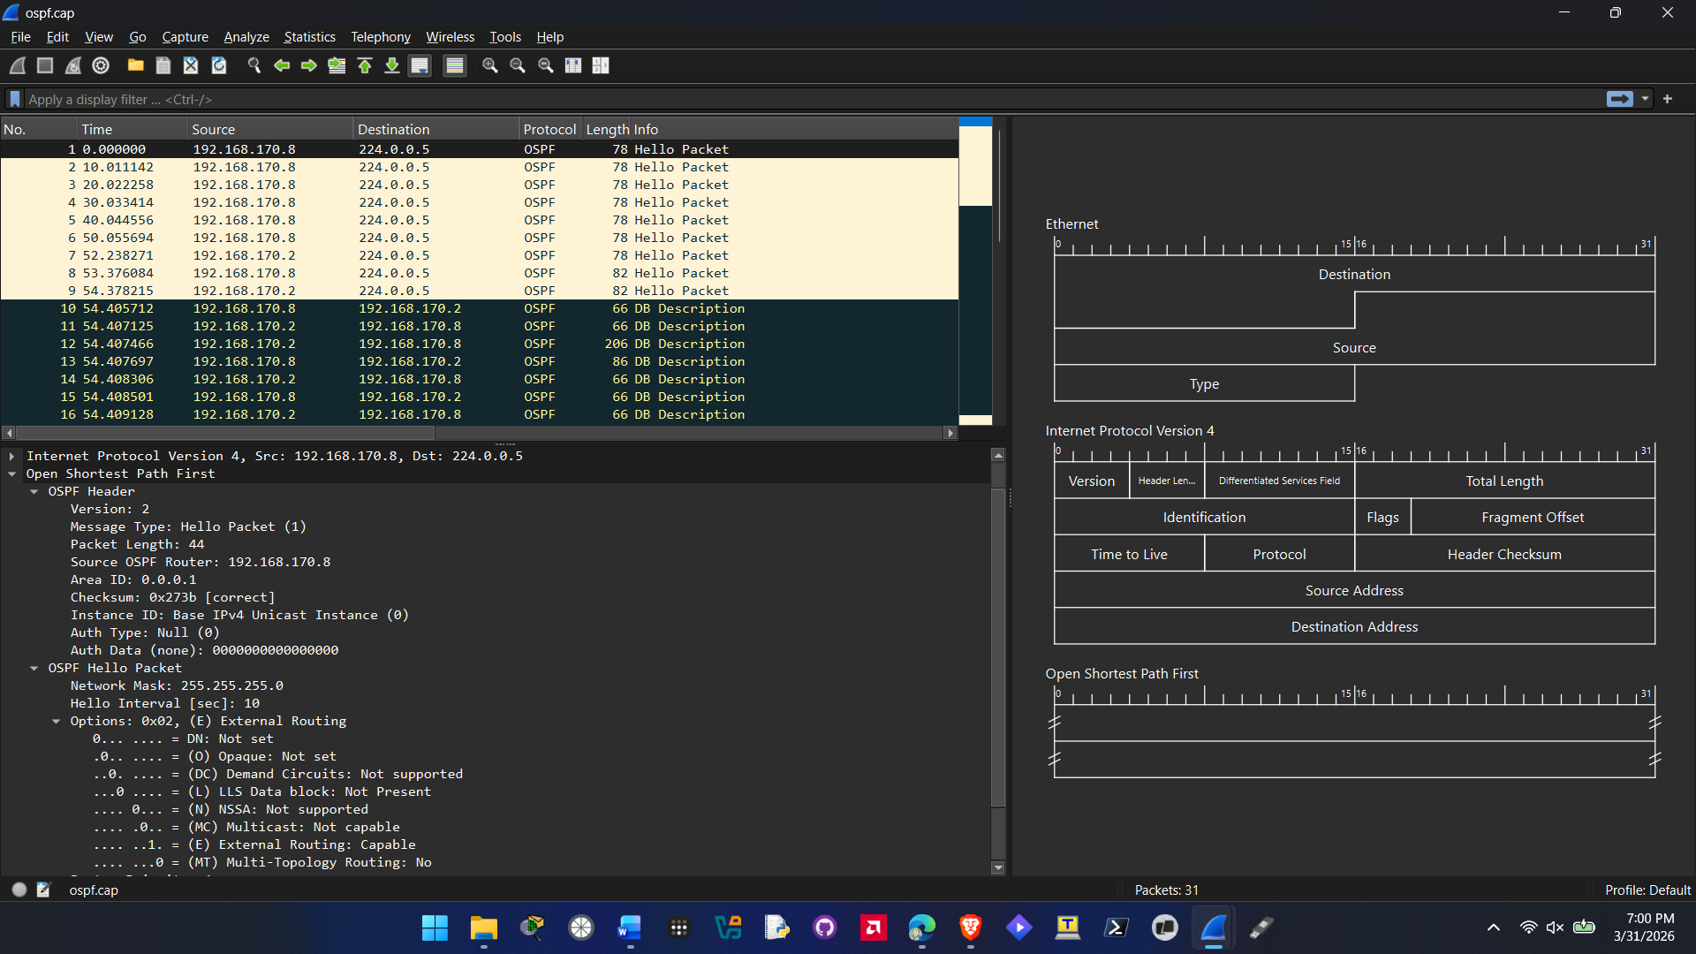
  - Screenshot of EIGRP hello packet with items expanded as requested
